Project Design Document

1. Design Intent
- The Experience: A high-precision, "sniper-style" competitive game. Unlike commercial IR laser tag that "sprays" light, this is about steady hands and accurate aiming. It creates a high-stakes, "one-shot-matters" atmosphere.
- The Audience: DIY makers, hobbyists, or friends looking for a low-cost, high-tech backyard game.
- The Problem: Professional laser tag equipment is expensive and often relies on "invisible" beams. This project uses visible lasers for immediate feedback and utilizes common, affordable components (LDRs/OLEDs) to make high-tech gaming accessible.

2. Inspiration & References
- How Real Laser Tag Works

3. User Journey
- The Start: The player dons the helmet and grips the gun. They flip a toggle switch. The OLED screen splashes a "SYSTEM READY" logo, the neopixel and settles on "LIVES: 03," strip turns on.
- The Hunt: The user creeps through a low-light environment. They see their opponent and squeeze the Trigger. A red beam streaks across the room.
- The Interaction: The player's beam hits one of the LDR sensors on the opponent's helmet.
- The Response: * Opponent Side: Their helmet MCU detects the sudden drop in LDR resistance. The OLED flashes "HIT!" and the life count drops to "02." The Neopixel strip flashes red for 3 seconds to indicate a hit.
  - Attacker Side: The attacker sees the opponent's flash, confirming a successful strike.
- Cooldown: There is a cooldown of 3 seconds after every 15 shots. There is also a 3-second invulnerable state for player who has just been shot.
- The End: Once a player's OLED hits "00," the screen displays "GAME OVER – DEFEATED."

4. Success Criteria
- Functional: Hit detection must occur in <100ms to feel "real-time." The laser must stay active only as long as the trigger is held (or for a set pulse duration).
- User Experience: The OLED must be high-contrast enough to read at a glance while moving. The helmet must be light enough to be comfortable for 15 minutes of play.
- Reliability: The system must distinguish between a laser hit and ambient room light (achieved through software thresholding).

5. System Overview
The system is a Distributed Wearable Network. Each "Player Unit" is a closed loop.
- The Brain (MCU): An Arduino Nano or ESP32 mounted on the helmet.
- The Peripheral (Gun): Connected via a "leash" wire, containing the laser diode and the trigger button.
- The Sensory Array (Helmet): 3–4 LDRs wired in parallel or to individual analog pins to provide 360° detection coverage.
- The Interface (OLED): A 0.96" I2C screen providing health and ammo status.

6. High-Level Block Diagram
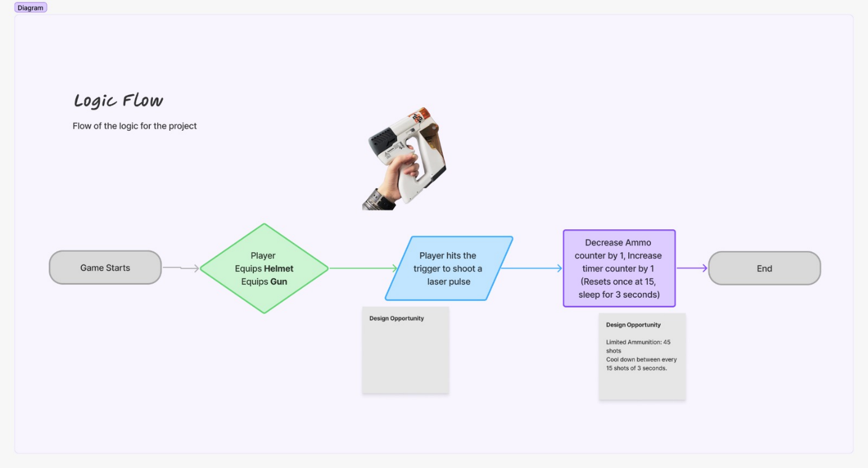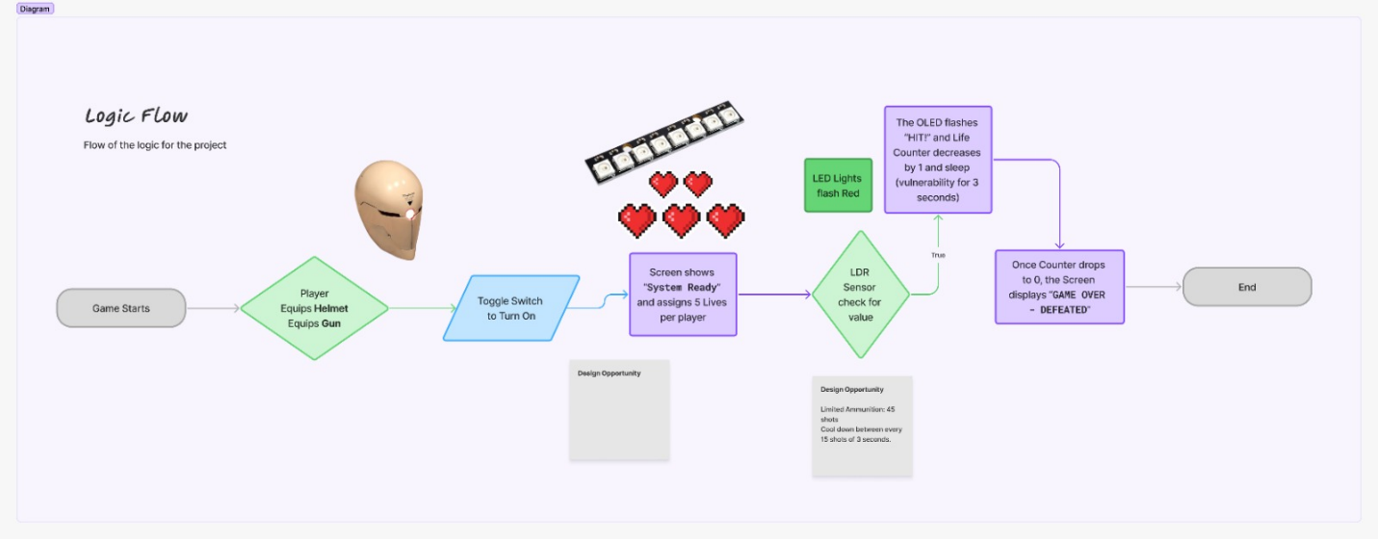

7. Input / Output Mapping
Input | Process | Output
Trigger Button (Digital Input) | Check if player has "lives" left. If yes, send power to Laser Diode. | Laser Beam (Red light emission)
LDR Sensor (Analog Input) | Compare light level to a pre-set "Threshold." If change is >40%, trigger "Hit Logic." | OLED Update (Lives -1)
LDR Sensor (Analog Input) | If "Hit Logic" is active, start a 2-second "Invincibility Timer." | Status LED (Red flashing)
Software Timer | Monitor time since last shot to prevent "Machine Gun" spamming. | OLED Animation ("Reloading...")

8. Sketches & Concepts
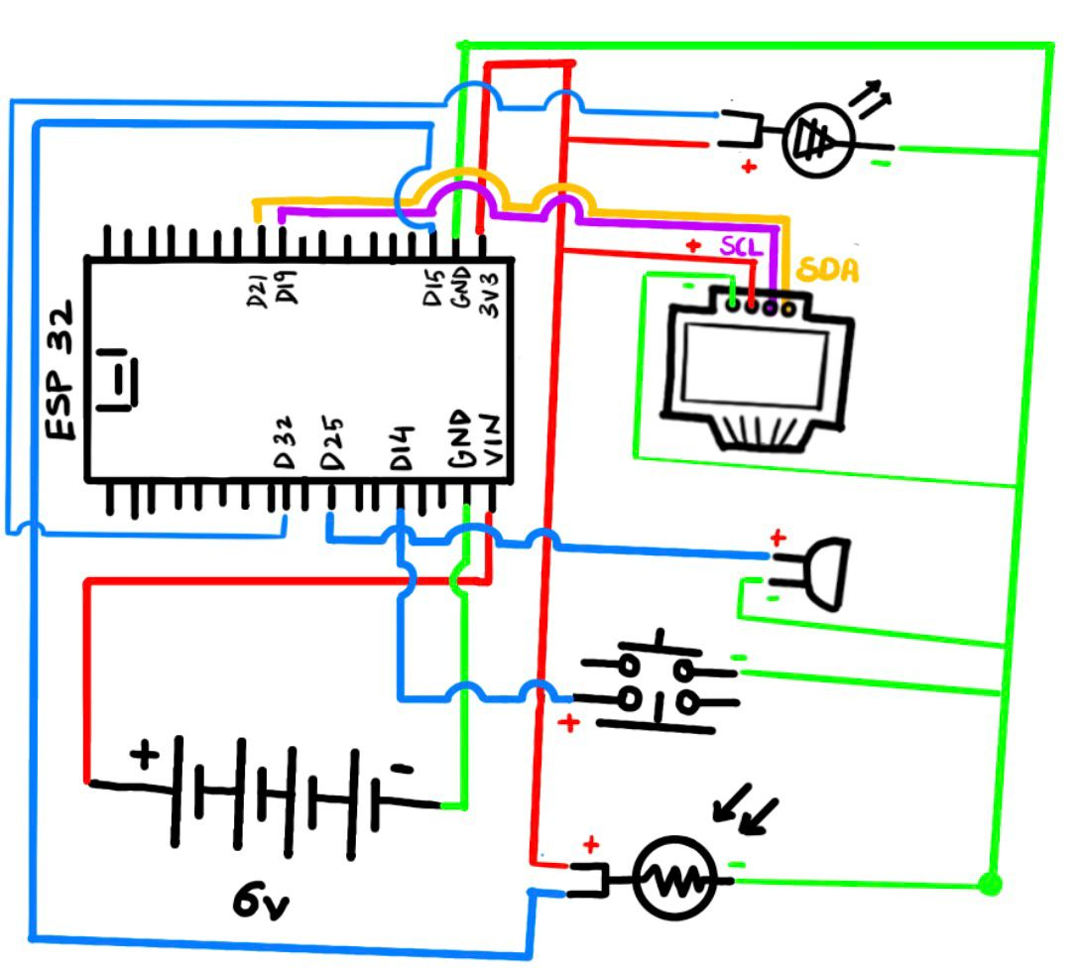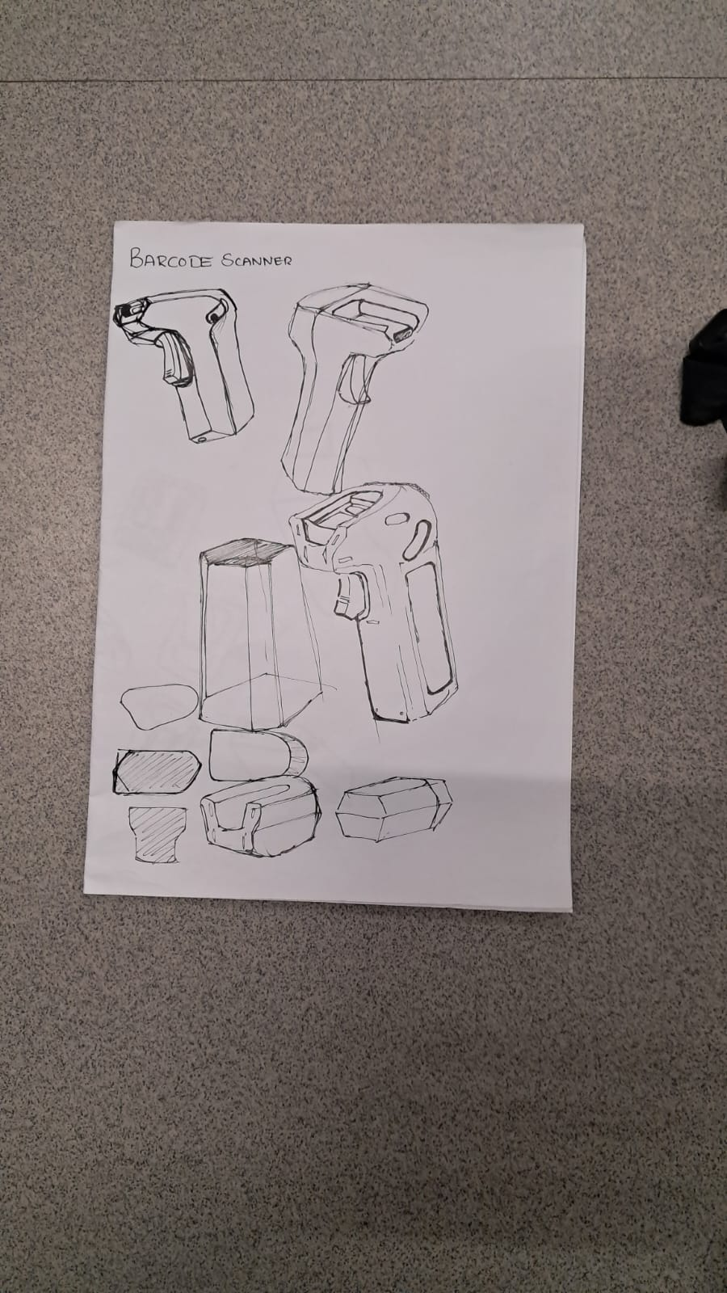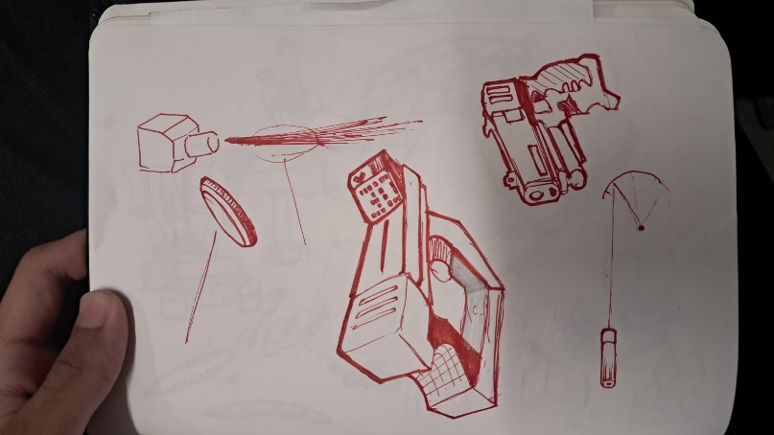

9. Final System Architecture (Labelled)
